For Immediate Release
March 22, 2024
Contact: Shannon Egan, Director, The Trout Gallery
717-245-1709; egansh@dickinson.edu

Upcoming Exhibition at The Trout Gallery
Celebrates Two Centuries of Black American Art

Carlisle, PA – The Trout Gallery is pleased to present an exhibition titled The Legacy of TWO CENTURIES OF BLACK AMERICAN ART, opening June 21, 2024 and on display through December 20, 2024.

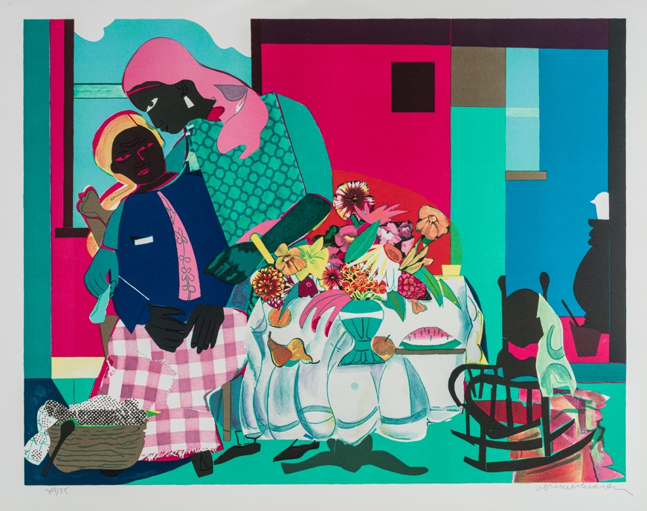
This exhibition celebrates the legacy of artist, activist, and curator David Driskell’s groundbreaking 1976 exhibition Two Centuries of Black American Art. Premiering in Los Angeles, and then traveling around the United States, this exhibition provided audiences with the first comprehensive survey of significant works made by Black artists. It broke cultural barriers and forever changed how African-American art was understood and appreciated across the country.

The Trout Gallery exhibition will not be a reconstruction of Driskell’s Two Centuries, but rather will educate visitors about his enduring significance and his championing of Black art, history, and culture. One of the central themes of the exhibition is a celebration of Black creativity and expression and is reflected in the motifs represented in various works, including dancing, music, family gatherings, and intimate portraits. Visitors are encouraged to see similarities and differences among the works across historical periods, particular artistic styles, and geographical locations. Additionally, the exhibition will feature a video about Driskell that includes clips of the film Driskell made in conjunction with the opening of the exhibition in 1976.

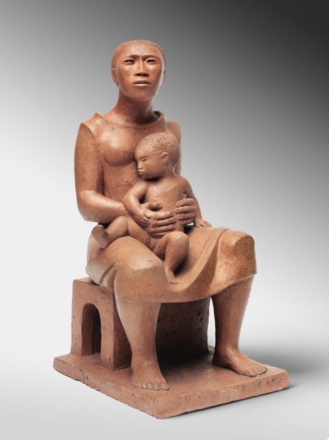
David C. Driskell (American, 1931-2020) was a trailblazing and esteemed African American artist and art historian whose achievements as a scholar, curator, and teacher left a profound legacy for countless artists and historians. . Born in Georgia and raised in North Carolina, Driskell attended the Skowhegan School of Painting and Sculpture in Maine before graduating from Howard University in 1955 with a BA in Fine Art. He received his MFA from Catholic University in Washington, DC in 1962. Scholars have noted that Two Centuries of Black American Art, which opened at the Los Angeles County Museum of Art, is one of his most significant curatorial contributions to the history of African American art and has shaped the way Black art is taught, exhibited, and collected. After teaching at Talladega College, Howard University, and Fisk University, Driskell was a professor in the Department of Art at the University of Maryland. After his retirement, the University of Maryland established The David C. Driskell Center for the Study of the Visual Arts and Culture of African Americans and the African Diaspora to acknowledge his legacy and impact as an artist and art historian.

The Trout Gallery will examine Driskell’s achievements by displaying a selection of artists featured in the exhibition and tracing their artistic careers and the themes in their works. Featured artists include Elizabeth Catlett, Jacob Lawrence, Romare Bearden, Alma Thomas, and Henry Ossawa Tanner, among many others. These works come from The Trout Gallery collection, the Philadelphia Museum of Art, the Historical Society of Pennsylvania, and a private collection.

This is one in a series of American art exhibitions created through a multi-year, multi-institutional partnership formed by the Philadelphia Museum of Art as part of the Art Bridges Cohort Program.

The exhibition will be accompanied by a full-color exhibition catalogue.

Public Events:
All events are free and open to the public.

Summer Community Day: July 7, 3pm to 8pm
Visitors are invited to participate in a celebration of Black art and culture. The Trout Gallery will host local Black-owned businesses and vendors selling arts, crafts, and food. Additional entertainment includes free live music, art activities, exhibition tours, a kids’ scavenger hunt with prizes, and a bounce house. This event is part of the Carlisle Summerfair series.

Reception: September 6, 5pm to 7pm
All are welcome to celebrate the current exhibitions on display with free pizza provided by the Dickinson College farm, live music, and beverages.

Fall Community Day: November 9, 12pm to 3pm
This Community Day provides an opportunity for visitors to see artworks made by community members in response to the exhibition. Additional activities include a scavenger hunt for kids, exhibition tours, and a dessert bar.

Symposium: Reflecting on the Legacy of David Driskell: November 9, 3pm to 5pm
Presentations by Curlee Raven Holton, artist, scholar, and Founding Director of Raven Fine Art Editions; Adrienne Childs, independent scholar, art historian, and Senior Consulting Curator at The Phillips Collection, Washington, DC; and Julie McGee, Associate Professor of Africana Studies and Art History, University of Delaware. The symposium will be moderated by Jerry Philogene, Associate Professor of Black Studies at Middlebury College.

Dates of Exhibition and Hours:
June 21 – December 20, 2024
Mondays – Saturdays, 10am to 4pm
Free admission

About The Trout Gallery:
The Trout Gallery is the art museum of Dickinson College. It is always free and open to the public. It is located in the Emil R. Weiss Center for the Arts at 240 West High Street, Carlisle, Pennsylvania, 17013.

As a teaching museum, The Trout Gallery promotes curiosity, collaboration, and understanding through active engagement with communities, ideas, and artworks. The Trout Gallery aspires to be a center for cultural and intellectual life on campus and in the community. Through exhibitions, collections, and educational programming, we foster interdisciplinary exploration and offer dynamic experiences that advance the values of creativity, expression, global diversity, and social justice.

Website: www.troutgallery.org
Facebook and Instagram: @troutgallery

About Art Bridges
Art Bridges is the vision of philanthropist and arts patron Alice Walton. The mission of Art Bridges is to expand access to American art in all regions across the United States. Since 2017, Art Bridges has been creating and supporting programs that bring outstanding works of American art out of storage and into communities. Art Bridges partners with a growing network of nearly 170 museums of all sizes and locations to provide financial and strategic support for exhibition development, loans from the Art Bridges collection, and programs designed to educate, inspire, and deepen engagement with local audiences. The Art Bridges Collection represents an expanding vision of American art from the 19th century to present day and encompasses multiple media and voices. For more information, please see:
https://artbridgesfoundation.org/wp-content/uploads/2021/11/Art-Bridges-Fact-Sheet-2021.pdf

About the Art Bridges Cohort Program
The Art Bridges Cohort Program is committed to supporting multi-year exhibition partnerships among museums nationwide. The program builds on Art Bridges’ mission to expand access to American art across the United States and to empower museums to broaden traditional definitions of American art. Originated in 2018, the Cohort Program (also known as the Art Bridges Initiative) has created seven museum cohorts led by institutions in Boston, Detroit, Fort Worth, Hartford, Los Angeles, Philadelphia, and Washington, D.C. For each cohort, an organizing museum invites regional institutions to create exhibitions that inspire and deepen engagement with local audiences. Sharing collections and resources, the program’s dynamic partnerships will generate over eighty exhibitions that are content rich, include in-depth educational and interpretive materials, and are designed to meet a wide range of audience interests. The program also fosters professional development exchanges between partners and across cohorts, facilitated by Art Bridges-supported staff at the organizing museums.

About the Philadelphia Museum of Art
The Philadelphia Museum of Art, in partnership with the city, the region, and art museums around the globe, seeks to preserve, enhance, interpret, and extend the reach of its great collections in particular, and the visual arts in general, to an increasing and increasingly diverse audience as a source of delight, illumination, and lifelong learning.
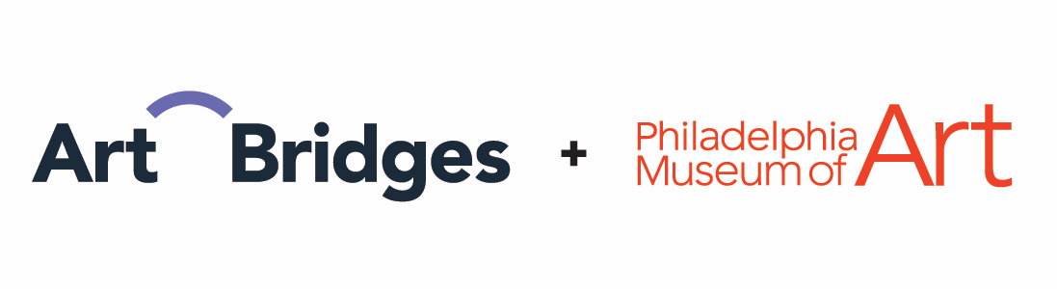

Image captions:
(above): Romare Bearden (American, 1911 - 1988), Morning, 1979, serigraph on paper, 22 x 27.75 in. (55.88 x 70.49 cm). The Trout Gallery, Gift of Darlene Morris, 2021.1.4.

(below): Elizabeth Catlett (Mexican, born United States 1915 – 2012), Mother and Child, c. 1956, terracotta, 11 1/2 x 5 3/4 x 6 5/8 in. (29.2 x 14.6 x 16.8 cm). Philadelphia Museum of Art: 125th Anniversary Acquisition. Purchased with funds contributed by Willabell Clayton, Dr. Constance E. Clayton, and Mr. and Mrs. James B. Straw in honor of the 125th Anniversary of the Museum and in celebration of African American art, 2000. 2000-36-1. Courtesy of the Philadelphia Museum of Art.

###

